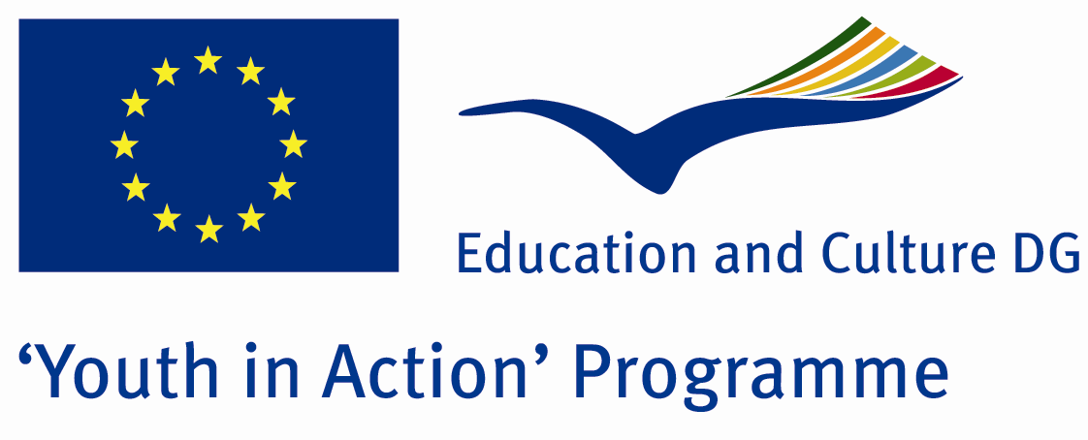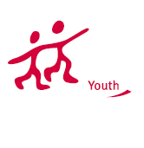

Different Languages
Common Emotion



ACTION 1.1 – Youth Exchange

23 - 30th July, 2011

Kirklareli, TURKEY

ACTION 1.1 Youth Exchange
23-30th July, 2011
Kirklareli, TURKEY

Please contact directly to;
adventurerpeacepigeons@gmail.com

Project Summary; We aim to prove we can understand each other even if we use different languages…Because emotions are not changed.they are the same for everybody…When we see a dog dies, everybody cries…when we see a baby, everybody plays with him.In this Project, one day we wont speak any language..just we draw,we use body language and we use some arts to talk about our opinions….one day, we will make heterojen groups and we use our own language…we wont use any english…and we will try to talk about our opinions..one day we will make a new language for our daily speak and we speak only this language…it will be different experiences…for you and for us…if you want, please contact with us…

Project Title; Different Languages Common Emotion

Date and Venue ; 23-30th July, 2011 Kirklareli, Turkey .

Target Group ; Municipalities, City Councils and Non-Governmental organizations,
youth groups,culture and art groups,e.t.c

Participants ; 5 people from each country (over 18 -25 ). Totally 8 countries.

Conditions ; Accommodation, board and programme costs will be financed through European Commission Youth in Action Programme (Action 1.1). Travel costs will be reimbursed in 70% (APEX Tarrifs). Organizations from all 27 EU member countries plus Liechtenstein , Norway and Iceland are eligible to take part.

Working language: English

Organizer; Discovery And Adventure Group

How to apply: If you are interested, please send your Part III forms to
0090 216 483 21 67 by FAX please. (Fulfilled Part III which you can find in the attachment, of course signed and stamped) ..

Note: jpeg is not allowed..please send by fax…

Next step 2;
Original send via regular post to this address please:

Ertan DERİN
Öner İnşaat
Abdulhalik Renda Cd.
Parlar Sk. No:4 Pendik/İSTANBUL

If you have any questions you may contact with: adventurerpeacepigeons@gmail.com

Deadline for application; until 20th January 2011.

For Further information:
Contact Person
Ertan DERİN
Öner İnşaat
Abdulhalik Renda Cd.
Parlar Sk. No:4 Pendik/İSTANBUL

e-mail : adventurerpeacepigeons@gmail.com
Mobile : 0090 542 393 93 90
Fax : 0090 216 483 21 67

